1. Objective of whole project.

Compare MADGE data to other machine learning algorithms like SVM and neural networks. Accuracy and speed will be the two most optimized features, with accuracy without overfitting as the most interesting piece to explore.

1. What was implemented last week.

Instead of trying to find an optimal sigma based on the range of the data, the training data was normalized to a 1x1 square range, as was each point.

The method is presented as follows.

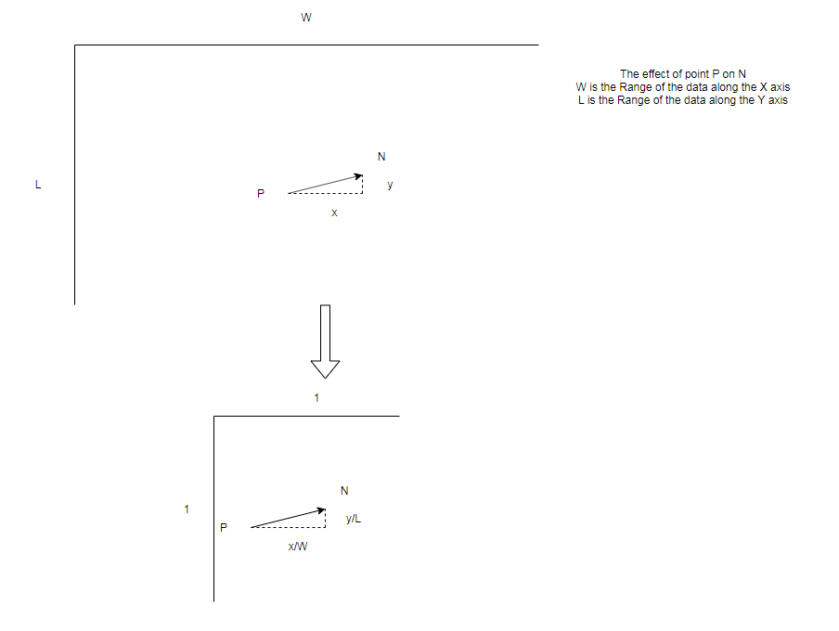

A sigma of ~0.02 was found to be the most optimal sigma (accuracy ~99%). Based on the range of the data being [1, 1], this sigma is about 2% of the range of each dimension. This is still an empirically tested value. There might be an absolute maximum. Theoretically, based on the range of the normalized data, there should be an empirical absolute maximum that we can determine.

1. Plans for upcoming week.

Find an optimal empirical sigma for stretched spiral data.

See if this optimal empirical sigma is the same for other stretched data. It should, since the range of the data has been normalized.

1. Objective of whole project.

Compare MADGE data to other machine learning algorithms like SVM and neural networks. Accuracy and speed will be the two most optimized features, with accuracy without overfitting as the most interesting piece to explore.

1. What was implemented last week.

The week before, we discussed the various sigmas that were being tested showed accuracy that was not above ~70%. Those calculations tested sigmas were using the same f values, regardless of what the range of the data are.

$$Weight= \frac{s}{s+t}Distance\left(a ,N\left(x,\frac{W}{f}\right)\right)+ \frac{t}{s+t}Distance\left(b, N\left(y,\frac{D}{f}\right)\right)$$

For a sigma of 1, a W of 1, and a D of 1000, our W/f would be 1 and our D/f would be 1000. If we adjust f, both the weight of the x Gaussian and the weight of the y Gaussian are adjusted equally.

There is no malleability of the weight of each dimension. I’ve been trying to test various ratios to see if there is a non-symmetrical sigma-width-ratio that is applicable here.

1. Plans for upcoming week.

Take a look at the Theil–Sen estimator for continued work.